Casa Bellesguard: the Link between the art of Antoni Gaudí and European Symbolism

Carles Rius Santamaria

(Paper presented at the coupDefouet International Congress, Art Nouveau European Cities: Between Cosmopolitanism and Local Tradition, Barcelona, June 2013)

Casa Bellesguard, until recently one of lesser known works by Antoni Gaudí, is erected in a site of great significance for the history of Catalonia: it is the place where the King Martí I (“The Human”) lived the last months of his life. There he received the bad news of his son’s death, Martí “The Young”; and there he married Margarida de Prades to try, without success, to father a new heir. A few months later, in May 1410, the king died, ceasing the House of Barcelona to exist, a Catalan dynasty with more than five hundred years. From 1900 to 1909, Antoni Gaudí built a house full of symbolism that seems to suggest by aesthetic means an alternative to the disenchantment and the decline of the country that had begun there five hundred years before. Generally speaking, a proposal like this one has been explained by the cultural context of the period: the Renaixença, a movement that demanded Catalan language and culture, and, within a predominant framework of strong Christian belief, hoped for the rebirth of the grandeur that the nation had lived during the Middle Ages . Also has it been linked to the ideas of German Romanticism expressed by authors such as Novalis, Friedrich Schlegel and Schelling, which pervade Catalan culture of 19th century through publications and the teaching of some lecturers. The whole of such Romantic ideas can be synthesised with the following narrative: a) “God created man in His own image” (Genesis 1:27); b) with the Fall, that original image nearly disappeared; c) Christians, however, can rediscover that original image in three ways: following the lessons of Jesus Christ, studying nature and knowing the history of various cultures; d) once the original image has been regained, the artistic genius can create works of art that contains it; and e) in this way, artist and interpreter can contribute to the Creation . It seems clear that it was this narrative that in German Romanticism, as in the Catalan Renaixença, stimulated a great symbolic creativity that sharpened the sensitivity for the nearest things, giving them, at the same time, a transcendental and open meaning .
Nevertheless, in a piece of research I began in 2002 and that I published in 2011 in a book entitled Gaudí i la quinta potència. La filosofia d’un art (Gaudí and the fifth Power. The Philosophy of an Art), I prove that, in Casa Bellesguard, Gaudí left a message that, being adequately brought to light, allows us to understand in a more precise manner the way those ideas are present in this work; and, in addition, opens a new path of research that allow us to link the work of Gaudí with European Symbolism. Next it is my intention to present in a few words the main parts of this piece of work .
To begin with, in a visit to Casa Bellesguard one can verify that, in this work, Gaudí, in a rather Socratic method, is suggesting the visitor a succession of impressions and steps to take until he ends up in a cul-de-sac that can only be overcome by a more daring procedure . Thus, when entering the land adjoining Casa Bellesguard, one can find to the left the ruins of the castle where King Martí I lived, soberly restored by Gaudí and contrasting with the expressive force of the house built a little further away by himself. Entering to the right, in front of the ruins of the castle, there is a cross that has a base made of “trencadís” (the characteristic mosaic used by Gaudí) that represents a rough sea from which emerges a helical shaft ending in a two-armed cross. This representation creates an atmosphere that will pervade the whole work: the sea can be understood as the unconscious just as the Romantics understood it, that is to say, not only a psyquic unconscious, but also a cosmic one, the chaos into which humanity dropped after the Fall. And in this unconscious ground something happens, as if a spark produces a lifting force that ends up in the cross. This group of elements anticipate what will later be found in the spire of the house, which culminates in a Catalan flag, a crown and this time a four-armed cross. After taking the entrance path, we will be situated in front of the main façade of the house built by Gaudí: a work of neo-Gothic style, with imposing verticality.

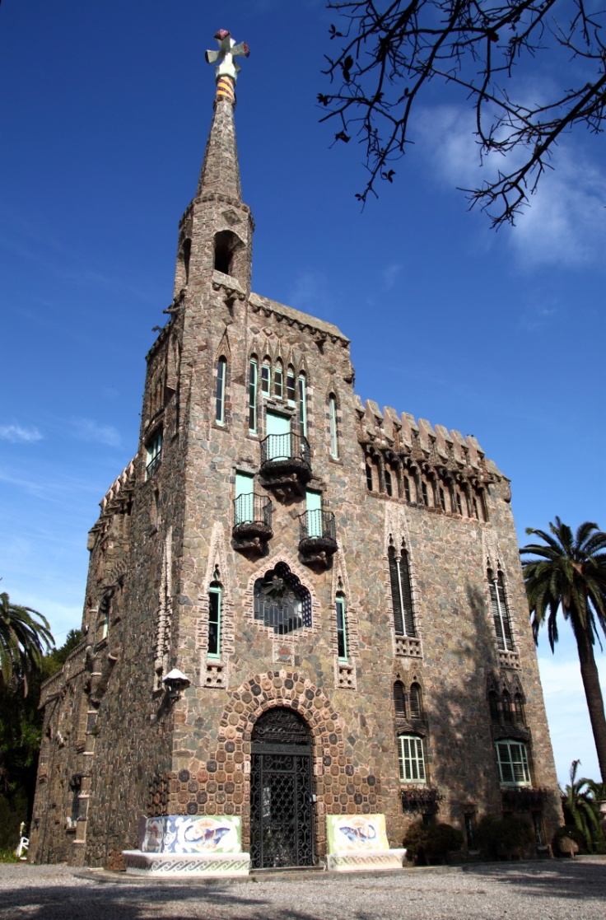
Fig. 1. Main façade of Casa Bellesguard (Barcelona), built by Antoni Gaudí from 1900 to 1909.
(Author of the photograph, Carles Salillas. Image courtesy of Guilera family, owner of Bellesguard. All Rights Reserved.)

On this façade the hierarchical and symmetrical forms of its left side stand out, in which there is a centre of attraction: a stained-glass window with a multicoloured embossed star, which transmits a mysterious feeling of harmony and retreat, the meaning of which, however, seems to be beyond what is seen in the foreground. It is just at the top of this part where there is the spire with the three aforementioned constituents: the helical Catalan flag, the crown and the four-armed cross, the later pointing towards the four cardinal points. These three elements, which express the force that now emerges from the inside of the house, can be understood as symbols of: the rebirth of the Catalan nation, the recovery of sovereignty, and the expansion of the Christian message, respectively. In fact, the general impression one has when contemplating the whole exterior of the house, is that the artist wants to suggest the visitor, by means of high and inaccessible openings, and by aggressive forms in details made of iron and displayed in grilles and window-boxes, that something very valuable that is inside is being defended from the outside; but, at the same time, this is presented in such a burlesque manner, that the visitor is tempted to go in to discover what is such valuable thing that is worth preserving by all means.
Before entering, one finds on the lintel of the door an inscription that reproduces a traditional greeting in this country, which refers to the dogma of the Immaculate Conception, and that reads: Ave Maria Puríssima, sens pecat fou concebuda… (“Hail Mary ever-pure, born without sin…”). As soon as one has gone in, one is surprised by the austerity and the brightness that prevails, only altered in a contrasting manner by the vividness of some stained-glass windows such as the multicoloured star, which from inside seems to expand like a beating heart. Moreover, one can verify that the verticality of the work seen from the outside continues inside, suggested by folded, helical and ribbed forms, and especially experienced in a disturbing manner as one walks up the stairs, which gradually narrow down as if they were stages of an initiation process. Once one arrives upstairs, however, the space widens up again in the two attics: the first covers a spacious square constructed with ingenious combinations of bricks; the second, also square shaped but smaller, forms a confined and silent space with a cross vault, where one perceives a very special light: thick and intense, suggesting by plastic means the states of ecstasy narrated by medieval mystics. At this point, one can go outside, where narrow zigzag flights of stairs take to a small terrace situated above the second attic: it is the highest accessible space of the house, near to the spire, and from which one can enjoy a wonderful view to the harbour of Barcelona, making it possible to see the ships arrive and leave.
Nevertheless, after having visited the interior of the house, one can not help feeling disappointed and confused: there is nothing that indicates the origin of that lifting and promising force that has been perceived from the ouside, and that also inside only finds an indirect expression by means of the light. The search, therefore, has to go on and in a deeper way. And then, when reading what has been said and written about this work of Gaudí −that until now has been very few−, one will find two notable pieces of information −at least, so they seemed to me−: the fact that, in this work, Gaudí, as an exception, did not want the help of any of his regular collaborators; and also that once the work was finished, several architects have wondered how did Gaudí manage to make the attics stand .
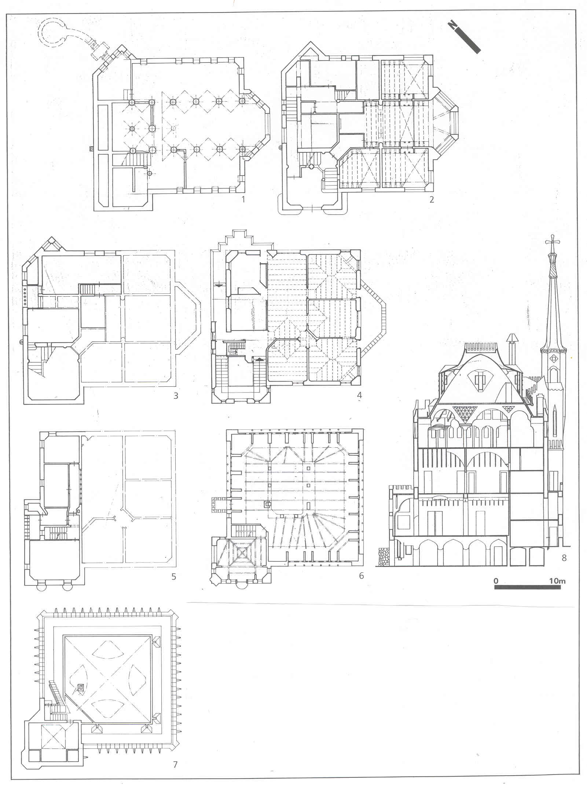
Fig. 2. Plans of Casa Bellesguard.
(Carles Rius Santamaria, Gaudí i la quinta potència. La filosofia d’un art, Barcelona, Publicacions i Edicions de la Universitat de Barcelona, 2011. All Rights Reserved.)
From these facts, it is important to analyse the plans of Casa Bellesguard. When carrying out it, one will notice that in this work by Gaudí a squared base stands out, which can be seen clearly in the plans of the attics. And as well as that, the diagonal lines of the squared base point towards the cardinal points, as it does the four-armed cross. Besides, when analising the concentric figures of this squared base on the attics’s plan, one can infer the three basic figures of the Euclidean geometry: the square, the circumference, and the triangle. And also, in the plans of the two main flats of the house, one can see a similar layout that consists of a central nave around which the rooms are arranged; but the two naves of the flats are situated at a right angle, so that if one superimposes the two plans, in the squared base one can see also the form of a Greek cross. In other words: one can verify that in the plans of Casa Bellesguard a squared base in which the square, the circumference, the triangle, the Greek cross and the diagonals can be clearly distinguished, stands out. These figures have the same central point, which in the vertical section of the building fits with an axis. This central point-axis is the one already alluded as a force in the helical shaft of the cross, in some decorative elements and in the helical flag of the spire. But after analysing the plans one has found its final location in Casa Bellesguard: in the very middle of the squared base, as a centre of the work’s geometry. Still, this does not explain much, seeing that one can notice that this central point-axis does not coincide with any decorative or functional element inside the house, so that it could explain why this central point-axis becomes that force sensed in other places of the work. In short: at the end of the analysis of the plans one becomes aware that in Casa Bellesguard, from the very beginning, everything is organised in such a way that all the decorative and geometrical forms allude to a central point-axis; but the meaning of this central point-axis is not in Bellesguard, and consequently, has to be searched outside, in another place.
In order to find such a location, one has to start analysing again the plans to see if one can discover something that indicates where to look for this second place. As a result, one can see that, apart from the squared base, there are several salient parts; and that among these salient parts some of them form a certain kind of unity, that is: the part where there is the house main entrance door (southwest façade), a strip along the northwest façade, and a right angle on the northeast façade. And the unity that these parts form is one that can be understood as an arrow, which at the same time can be interpreted as a boat . A soon as one locates the arrow-boat form in Casa Bellesguard, considering that the diagonals of the squared base mark the cardinal points, if one situates the house in a map of Europe and draws a line that goes along the keel of the boat and leaves from the tip of the arrow, this line will go through several places of Catalonia, France, Italy and Central Europe. Then the question is to which place exactly Gaudí pointed from Bellesguard and why. In order to know this, what I did was to read what Gaudí’s biographers had written to see if I could find any piece of information about a possible relationship between Gaudí and Central Europe. What I could check was that Gaudí had not travelled much, or at least it is not recorded that he had in that direction; but that he had indeed read a lot. And what did Gaudí read? Many things, but above all there was a book that he read again and again: L’Année Liturgique by Prosper Guéranger. Who was this author? Prosper Guéranger (1805-1875) was one of the initiators of the Catholic liturgical movement of Romantic kind. In 1833, he began to restore the Benedictine life in the monastery of Solesmes, on the outskirts of Paris, becoming his abbot in 1837, and promoting Gregorian chant. So far, this is what Gaudí’s biographers say about Guéranger and the importance of his work for the Catalan architect. But all this happened in the north of France, in Solesmes, and the line of the arrow-boat that leaves Casa Bellesguard heads towards Central Europe, towards Germany. Therefore, it was necessary to find out if there had been some relationship between Germany and Solesmes. From this point, I carried on researching, and found the following. In 1862, in Baden-Württemberg, in a place named Beuron, a monastery was built and a new Benedictine Congregation was founded. His abbot, Maurus Wolter, with another monk, Roman Sauter, travelled to Solesmes to study its theories about Gregorian chant. Later, they went back to Beuron, and then they tried to apply the mathematical relations that were used for music in Solesmes to fine arts, forming a new school: the Beuron Art School. The early leader of that school was Peter Lenz (1832-1928), who once had entered as a monk in the Order, adopted the name Desiderius Lenz. In 1871, when the Chancellor Otto von Bismarck established the new German Empire (“Second Reich”) and launched what is known as Kulturkampf (“Culture Struggle”), persecuting some institutions of the Catholic Church for considering them little liberal, some monasteries were closed and the monks of the Beuronese Congregation had to emigrate to other European countries. One of the places they went to was near Prague, Smíchov, where in 1891 a convent of nuns was built, St. Gabriel’s Abbey. And a few years later, in 1895, Peter Lenz and his team of artist-monks were asked to paint the church of the convent, dedicated precisely to the Annunciation of Virgin Mary, and they did so until 1899. Well, it turns out that the line drawn from the arrow-boat of Casa Bellesguard goes through this convent. Consequently, St. Gabriel’s Abbey may be the place where Gaudí had pointed to from Casa Bellesguard .
In order to know if St. Gabriel’s Abbey is really the second place we were searching, it is necessary to compare the two works, to try to see if there are relations between them and, in this case, which they are. So, firstly, if one superimposes the plan of Casa Bellesguard on part of the plan of St. Gabriel’s Abbey, so that the arrow-boat of the first coincides with the nave of the church of the second, one will observe several lines that match up; and besides one will see that the form of the capitals of the columns in Casa Bellesguard ara very similar to the ones in the cloister of the convent. Secondly, since this first superimposition has been done, one can notice that the left side of the main façade of Casa Bellesguard, the side that surprised me the first time I saw it by its harmonic unity, matches with the place where the apse is in St. Gabriel’s church, so that with a second superimposition between the lines of that side of Casa Bellesguard and the paintings in St. Gabriel’s apse, one can check that the first is a stylisation of the second. Thirdly, the window with the multicoloured star in Casa Bellesguard proves to be a stylisation of the painting that occupies the centre of the church apse in St. Gabriel: a work painted by Lenz and entitled Mater Dei-Isis because it represents the Mother of God with Baby Jesus, but who, at the same time, is the Egyptian goddess Isis with her son Horus. And finally, once the boat of Casa Bellesguard has been situated on the nave of St. Gabriel’s church, one can see that the bow of the ship of Casa Bellesguard points to the choir of the nave of St. Gabriel’s church: Is there anything interesting in St. Gabriel’s church that justifies such a sign? Indeed, there is a large sized fresco entitled The Piety: the most important work by Peter Lenz, the one he devoted most of his time and efforts to. Experts praise these two works, the painting Mater Dei-Isis and the fresco The Piety, but at the same time they admit that they have a cryptic symbolism that is difficult to decipher . Some of these experts also point out that this symbolism is related to a theoretical side in Lenz’s work. Therefore, it is important to study this theoretical aspect of Lenz’s work, that he called “aesthetic geometry” .
The geometry of Lenz has aesthetic, ethic and religious connotations, and it comprises a series of figures that can be summarised as it follows. Its basic forms are: a) the square, that symbolises the Father; b) the triangle, that represents the Son; and c) the circumference, that is equivalent to the Holy Spirit. The gathering of these three forms makes up a figure that Lenz calls the der Schlüssel-Gottes (the key of God) because he considers that it is possible to construct all the other figures taking this one as a starting point. So forms are further complicated until one manages to geometrically represent the first man and the first woman, Adam and Eve, which Lenz calls “the Canon”. In the end, the most complete and complex figure of aesthetic geometry appears: the sphere of the five regular solids, which, according to Lenz, expresses “God’s instruments to form the sacred”. In fact, this sphere was already worked by Plato, Euclid and Kepler, but Lenz gave the figures a different order. The order of the figures in Lenz is, from the outermost to the innermost: dodecahedron, cube, octahedron, tetrahedron and icosahedron. In Lenz’s opinion, with the Fall all this geometry almost disappeared, and he believes that in the history of mankind there has been one moment in which this divine geometry appeared again: in Christianity, in Incarnation, the dogma of the Word made Flesh. However, men can rebuild such a geometry by studying nature; and they can also do works of art that contain it. In other words, one can see that the main ideas of Lenz’s aesthetic geometry coincide with the narrative of German Romanticism I have mentioned before: “God created man in His own image”; with the Fall, that original image nearly disappeared; men can rediscover that original image studying nature; and the artistic genius can create works of art that contain it, so that artist and interpreter become collaborators in the Creation. Yet it occurs that Lenz has a geometrical conception of that original image. And this, in my opinion, he got it from the hermetic tradition, which, rooted in the culture of ancient Egypt −a culture that Lenz especially admired −, had been recovered and studied during German Romanticism.
Only after examining deeply the theoretical side of Lenz’s work, it is possible to interpret adequately the two main paintings in St. Gabriel’s Abbey.

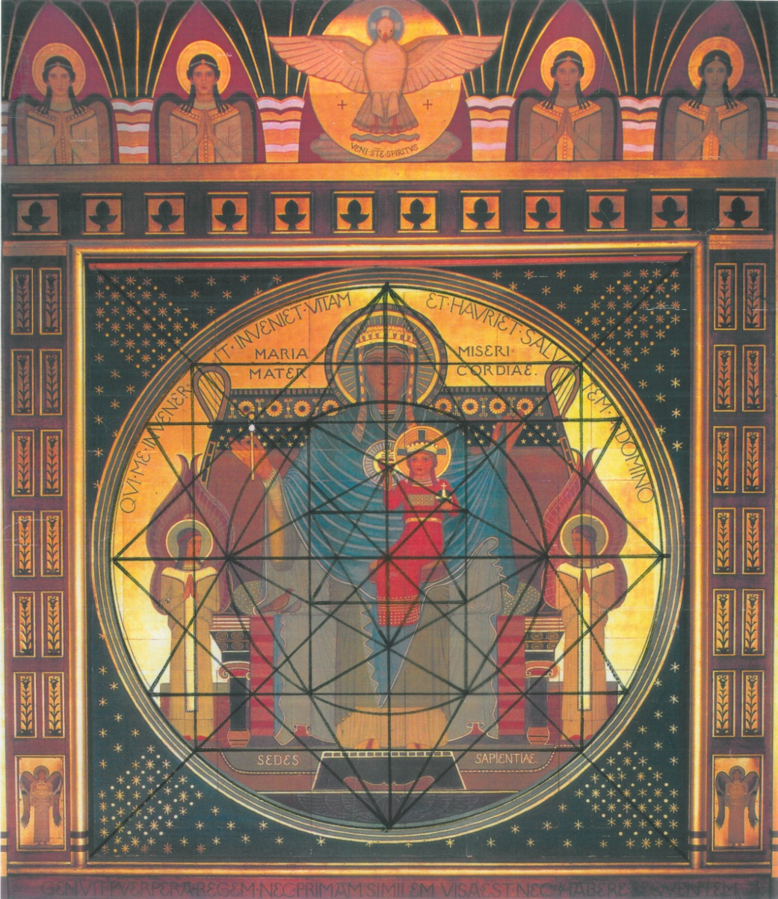
Fig. 3. Application of the aesthetic geometry to the painting Mater Dei-Isis, a work done by Peter Lenz in 1898, at the church of St. Gabriel’s Abbey, Prague.
(Author of the drawing, Carles Rius Santamaria. Authors of the photograph, Oto Palán and Michal Seba. The photograph of the painting is in the archive of the Society of Friends beuronského Arts, in Prague. All Rights Reserved.)
Thus, as I have said above, with regard to the painting Mater Dei-Isis it represents the Mother of God-Isis with the Baby Jesus-Horus on her lap . But in this work one can identify the next forms of aesthetic geometry: the square, the triangle, the circumference, the Greek cross and the diagonals; in addition, the duplicated and inverted square and triangle, so that an eight-pointed star appears as well as several concentric six-pointed stars, that is to say, hexagrams. The first forms I have mentioned are the same I have situated above, in the squared base of Casa Bellesguard, when I presented a first analysis. There, in Casa Bellesguard, we see that these forms have the same centre: the central point-axis we do not know anything about, and which has just been the cause for our research in a second place. In the painting Mater Dei-Isis, these forms also have a central point, but here this centre coincides with the womb of the Mother of God-Isis. That means that, in the foreground the painting represents the Virgin Mary-Isis with the Baby Jesus-Horus, but in the background the work symbolises the conception of Mary and also that of Jesus Christ, the Incarnation, intermingled with the Egyptian myth which explains that Horus was born from the reconstruction that Isis made of Osiris’ chopped body. Therefore, this work is done in a way that the interpreter has to discover aesthetic geometry in it, until he gets inwardly the representation of the sphere of the five regular solids, in which centre there is the icosahedron, which in the painting coincides with the womb of the Virgin Mary-Isis: this is the same sphere that, according to Lenz, was present in the Incarnation and from which God created the first man and the first woman. The inward representation of this sphere produces in the interpreter an aesthetic sparkling experience that is precisely expressed in the painting by the diagonals formed by bright stars.
Now one can go on the analysis of the fresco The Piety, also through aesthetic geometry. This work represents the Virgin Mary with the body of Jesus Christ on her lap, who is at the same time the goddess Isis with the body of her husband-brother Osiris. In general, dark shades predominate in this painting, which gives it a rather gloomy aspect. But there is also a detail that seems to point out another phase: bright spots, some of which form a circle that is at the centre of the picture, where is the body of Jesus Christ. Here the central point of this circle also coincides with the womb of the Virgin Mary-Isis, so that again, having identified the forms of aesthetic geometry implicit in the work, the interpreter can imagine the sphere of the five regular solids, the centre of which, the icosahedron, coincides with the womb of the Virgin Mary-Isis. As it happens in the painting Mater Dei-Isis, this sphere refers to the moment of the Incarnation, and also to the creation of the first man and the first woman by God, but here it is also alluding to the Resurrection of Jesus Christ and the birth of Horus from the body of Osiris, that is: Resurrection conceived as a rebirth. In addition, in this work, at the end of the interpretation one can form a mental image of a little white Greek cross on the left side of the picture, above the heap, where there is the inscription Sion coel ests. This little white cross symbolises, in a stylised manner, the Heavenly Jerusalem as it appears in the Apocalypse of St. John, that is: the arrival of the time of spirit, where one will find again the tree of life at the centre, the return to the origin, but existing in its completness. This representation is important because with it the image achieves perfect symmetry .
To sum up, after these interpretations of the painting Mater Dei-Isis and the fresco The Piety by means of aesthetic geometry, these two works show themselves as particular exemples of works of art as they were understood by German Romanticism: they try to present here, on earth, the original image, conceived with a cryptic language that being adequately deciphered turns the artist as well as the interpreter collaborators in the process of Creation.
Yet it is worth mentioning that Peter Lenz did not only apply aesthetic geometry to painting, but he also tried to apply it to architecture. So, first, he and some of his pupils tried to discover this divine geometry in some of the great temples built in the history of mankind (ancient Egypt, Greece, Rome and the Christian era) . Second, he also drew up some plans for a large church that would have included styles of different cultures and religions. However, Lenz could never put into practice this application of aesthetic geometry to architecture.
Then, once Peter Lenz’s work in St. Gabriel’s Abbey is understood, and with it the meaning of the central point-axis of Casa Bellesguard, that is, the Resurrection conceived as a rebirth through a divine geometry, we can return to the work by Antoni Gaudí and verify if it is now possible to understand it better. As a result of applying principles of aesthetic geometry to the squared base in Casa Bellesguard, this can be interpret as it follows:

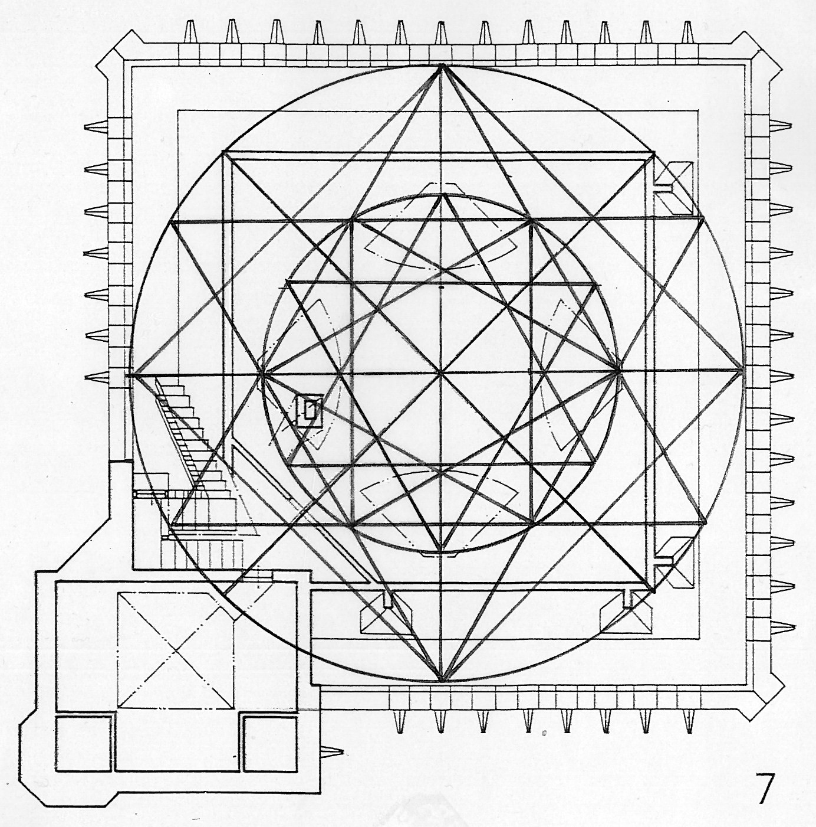
Fig. 4. Application of the aesthetic geometry to the plans of Casa Bellesguard.
(Author of the drawing, Carles Rius Santamaria. All Rights Reserved.)
This application of aesthetic geometry to the squared base of Casa Bellesguard, in a three-dimensional space, corresponds to the presence of the sphere of the five regular solids in the attics; it is the situation of this sphere in this place that determines the structure that makes it possible for the attics to stand.
All in all we can see that in Casa Bellesguard Gaudí proceeded as Lenz in St. Gabriel’s Abbey: a work of art that contains the original image from which God created man, understood in a geometrical manner. The difference between Lenz and Gaudí is that the former only did it in painting, whereas the later, succeeded in applying aesthetic geometry to architecture. In addition, by doing this in Bellesguard, Gaudí tried to use the aesthetic effects of this geometry to demand the culture of his country: with the presence of the sphere of the five regular solids that had brought about the Incarnation and the Resurrection of Jesus Christ, but in the place where five hundred years before his homeland had started to decline −had “fallen”, so to speak−, so that Renaixença, the rebirth of the Catalan nation, were more likely to happen.
In spite of this, Gaudí did not confine himself to using Lenz’s geometry in Casa Bellesguard. If, as we have seen, aesthetic geometry has a religious meaning, could Gaudí have used its principles in his most pious work, that is, the Temple de la Sagrada Família (Church of the Holy Family)? In my opinion, the answer is affirmative. The dimensions of the squared base of Casa Bellesguard are very similar to the ones of the crossing of the Sagrada Família; and, moreover, the diagonals of the crossing, as well as the ones in the squared base in Casa Bellesguard, are pointing towards the four cardinal points. Then the application of aesthetic geometry that has been done in Casa Bellesguard, can also be used for the crossing of the Sagrada Família. And therefore, the structure of the five regular solids that explains how the attics of Casa Bellesguard stand, can also be used for building the tower of Jesus Christ in the Sagrada Família, the main and highest tower of the Temple, which, as the spire of Casa Bellesguard, has to be crowned by a four-armed cross. In other words: Gaudí built Casa Bellesguard with the aesthetic geometry of Lenz because he also wanted to leave a legacy that showed how he had thought that the Temple de la Sagrada Família should be ended.
Before I finish, I would like to say a few words about a more historical research I did in parallel with the one I have tried to summarise in this paper, in relation to the question of how did Gaudí manage to obtain all the information on what Peter Lenz had done in St. Gabriel’s convent if he did not travel to Central Europe. After having studied several hypotheses, I consider that all the signs are that Gaudí got that material from the three brothers Jaume, Joan and Francesc Figueras, the sons of the widow Maria Sagués, the woman that in 1900 commissioned Antoni Gaudí to build Casa Bellesguard. Two years before, in 1898, Gaudí joined the Cercle Artístic de Sant Lluc (Artistic Circle of Saint Luke), a group of Catholic artists to which belonged the Figueras brothers; and in the same year, Gaudí, these brothers and other artists formed also the Lliga Espiritual de la Mare de Déu de Montserrat (Spiritual League of the Virgin of Montserrat), a Catholic group that supported Catalan autonomy .
In conclusion, the discovery of the message that Antoni Gaudí left hidden in Casa Bellesguard, the link with the work of Peter Lenz, allows us to understand better than before several things: a) the meaning of the forms and structures of Casa Bellesguard; b) the close relationship between this work and the Temple de la Sagrada Família; c) the meaning of symbolism in Gaudí’s work: spreading the Christian message and the ideal of Catalan sovereignty (Christian Resurrection and Catalan Renaixença) both through the revitalizing effect that produces the artistic use of a divine geometry; and d) a line of continuity between German Romanticism, European Symbolism, Art Nouveau and the work of Antoni Gaudí. In my opinion, this discovery opens up new perspectives on the study of Gaudí’s life and work.

In Catalan, “Renaixença” means literally “rebirth”. Some of the main figures of this movement were: Pau Milà i Fontanals (art history and painting); Jacint Verdaguer (poetry); Àngel Guimerà (drama); Narcís Oller (prose); Francesc Xavier Llorens i Barba, and Manuel Milà i Fontanals (philosophy); Elies Rogent (architecture); Claudi Lorenzale, and Lluís Rigalt (painting).
Some works by Romantic authors where one can see reflected this narrative are: Johann Gottfried Herder, Vom Erkennen und Empfinden der menschlichen Seele (1778); Wilhelm Heinrich Wackenroder, Herzenergiessungen eines kunstliebenden Klosterbrüders (1797); Novalis, Die Christenheit oder Europa (1799); Friedrich Schlegel, Ideen (1798-1800); and Friedrich Wilhelm Joseph von Schelling, System des transcendentalen Idealismus (1800).
On this subject, see: Carles Rius Santamaria, “El pensamiento de la Bildung: de la mística medieval a Philipp Otto Runge”, Convivium. Revista de filosofía, núm. 23, 2010, p. 49-72; and Carles Rius Santamaria, “La funció de l’artista en el pensament romàntic alemany”, Comprendre. Revista catalana de filosofia, 13/2, 2011, p. 105-131.
The results of this piece of work I presented first in 2006 as a PhD thesis at the Faculty of Philosophy at the University of Barcelona, entitled Interpretació de l’obra d’Antoni Gaudí a través del pensament de F. W. J. Schelling. Subsequently, in 2011, a synthetic version of this thesis was published in the book Gaudí i la quinta potència. La filosofia d’un art, Publicacions i Edicions de la Universitat de Barcelona.
The idea of conceiving a work of art as a “subject” that can address to us and move us to search something that is hidden in the work itself, is an idea that appears implicitly in the text of Johann Georg Hamann, Sokratische Denkwürdigkeiten (1759), and then spreads to German Romantics and other artists of the 19th century, such as Philipp Otto Runge.
According to Joan Matamala, Joan Rubió i Bellver, one of the regular collaborators of Antoni Gaudí, said to him on one occasion: “Bellesguard wanted to plan and to manage alone Mr Gaudí, from beginning to end. He did not want us to help him”, Joan Matamala, Antonio Gaudí. Mi itinerario con el arquitecto, Barcelona, Editorial Claret, 1999, p. 140.
The idea that in Casa Bellesguard there is a part that can be considered as a boat is supported not only by the history of the place, from where the King Martí “The Human” looked at the harbour to see if he could distinguish a ship that brought him news of his son, but also because in this part of the house there is a bench made of “trencadís” in which a boat is just represented.
On St. Gabriel’s Abbey and the work that Peter Lenz and his team did there, see: Helena Cizinská (text), Karel Holub and Monica Sebová (editor), Die Beuroner Kunstschule in der Abtei Sankt Gabriel in Prag, Prag, Nakladatelství Karel Holub, Ars Bohemica, 1999.
The art of Peter Lenz is considered by some scholars as one of the expressions of Symbolism and one of the sources of Art Nouveau. In fact, some members of the Nabis group such as Paul Sérusier and Maurice Denis, through the artist and also monk of Beuron Jan Verkade, made contact with Peter Lenz just when he was working in St. Gabriel’s Abbey. Moreover, in 1898, was published in Vienna an essay written by Lenz entitled Zur Ästhetik der Beuroner Schule, over which it is said that the painter Gustav Klimt enthused; and in 1905 the art of Beuron was presented successfully in the exhibition of the Vienna Secession, and later in other cities such as Aachen (1907), Düsseldorf (1909), and Regensburg (1910).
About the life and work of Peter Lenz, see: Martha Dreesbach, «Pater Desiderius Lenz OSB von Beuron, Theorie und Werk», Studien und Mitteilungen zur Geschichte des Benediktiner-Ordens und seiner Zweige, Band 68, 1957; Hubert Krins, Die Kunst der Beuroner Schule. Wie ein Lichtblick vom Himmel, Beuron, Beuroner Kunstverlag, 1998; Desiderius Lenz, The Aesthetic of Beuron and other Writings, London, Francis Boutle Publishers, 2002; P. Gallus Schwind, P. Desiderius Lenz, Beuron, Kunstverlag Beuron, 1932; Harald Siebenmorgen, Die Anfänge der Beuroner Kunstschule. Peter Lenz und Jakob Wüger 1850-1875, Sigmaringen, Jan Thorbecke Verlag, 1983; and Adolf Smitmans, “Die internationale Rolle der Beuroner Kunstschule um 1905”, Erbe und Auftrag, nº 61, 1985.
It is important to bear in mind that during German Romanticism there was an increasing interest in mythology as a primary expression of religious meaning, whose creative potential could be used. See, for exemple, the concept of a “New Mythology” that appears in the text attributed to Schelling, Hölderlin and Hegel, entitled Das älteste Systemprogramm des deutschen Idealismus. In Catalan Renaixença we can see an example of this in the poem of Jacint Verdaguer “Afrodisius”, in Jesús Infant, La fugida a Egipte, (1893), where the figure of Virgin Mary is compared with the goddess Isis.
The importance of the writings of St. John, and especially the symbol of the Heavenly Jerusalem, spans in German thought from Lessing to Schelling; in this author, at the end of his Philosophie der Offenbarung, Lesson 37. On this matter, see: Carles Rius Santamaria, Schelling esencial. El arte es la única y eterna revelación, Barcelona, Ediciones de Intervención Cultural, Montesinos, 2011, p. 53-57. Also in Catalan Renaixença this symbol had an important presence; for example: Gaudí thought that a model of the Heavenly Jerusalem should hang from the centre of the crossing in the Temple de la Sagrada Família (Church of the Holy Family).
See: Odilo Wolff, Tempelmasse. Das Gesetz der Proportion in den Antiken und altchristlichen Sakralbauten, Wien, Verlag von Anton Schroll and Co., 1912; and Odilo Wolff, Der Temple von Jerusalem. Eine kunsthistorische Studie über seine Masse und Proportionen, Wien, Verlag von Anton Schroll, 1913.
The Cercle Artístic de Sant Lluc was created in 1893 in Barcelona, similar to the union founded in Vienna in 1809 by the German painters Pforr, Overbeck and others, the Lukasbrüder, who, in turn, were influenced by Romantic thinkers such as Wackenroder and Friedrich Schlegel. In 1810, the Lukasbrüder went to Rome, where they were also known as the Nazarenes, and where in 1812 Peter von Cornelius joined the group. Cornelius would later be the master of Peter Lenz. In Catalonia, the ideas of this group arrived first through Pau Milà i Fontanals, who in 1832 went to Rome, there he knew Overbeck, and later, in 1841, came back to Catalonia and taught the Nazarenes’ ideas to many artists of Catalan Renaixença. Antoni Gaudí is known to have attended some of his lectures. I explain all this historical research at the end of my book Gaudí i la quinta potència. La filosofia d’un art, p. 281-319.

